Sandstorms in the Middle East
Name of Student
Name of Institution
Date

Abstract
The erosion of sand from the surface of the earth by conventional current is more prevalent in the desert areas and more so the Middle East. The formation of the sand and the statistics pertaining the effects and impacts of the same will be analyzed in this paper. The information provided will also include statistical representation of the sandstorms and the impacts the same has to the society and different departments of nations in the Middle East. Analysis will also enclose details about the hospitalization rates of victims from sand storms, and also from pollutants relevant and encountered during sand storms.

Table of Contents
Abstract 2
Introduction 4
Methodology 4
Discussion 6
Conclusion 8
References 11
Appendices 12

Introduction
Sandstorms are the results of strong conventional currents blowing over loose sand or soil and have the capability of lifting the soils. The current presents as wind, and the soil lifted is pushed in the very direction of the wind. The particles of soils and sand lifted may range from 0.08 to 1mm in size and the strength of the currents determines the properties of the sandstorm. A huge probability of occurrence is during the day brought about by the heat on the earth’s surface which makes the particles loose, and they are generally unpredictable in terms of a point of origin. Through saltation, the particulates on the earth’s surface are vibrated to shake them loose and enable the gush of winds to carry the fine particles and form a storm. The gush of wind that brings about the phenomenon is either as a cause of strong pressure gradients, or the outflows of a thunderstorm.
The prevalence of the sandstorms can be attributed to a mixture of air with the intense heat experienced in the Middle East, which in turn is the reason behind the instability in the lower atmosphere. The mentioned instability merges with winds at the mid-section of the troposphere which results in string convectional currents on the surface of the earth. The sandstorms can pick so many particles under high convectional intensity that they appear as a solid wall. The characteristics of the storms are defined by the constituents that form them and the warning signs right before they occur. The same goes for their potential benefits and destruction. In China, April is marked as the sandstorm month. Sandstorms differ from dust-storms based on the particles, that is, the latter has finer particles. They are recorded to have the capability of reaching heights of up to 15.25 meters, usually shaped by the strength of the gust of wind. Mostly occurring in hit and desert regions, sandstorms can achieve speeds of 25 miles per hour lasting only a few minutes. They have an impact of reducing visibility and choking from lack of air. The sandstorms bring about siltation on the place where they deposit the loose sand and dust the winds collected.
Ramahi documents that in the week of July 30th in 2018, dust storms resulted in more than 1,000 road accidents in Dubai. Ramahi post highlights the effects of the heavy dust storm on two days; Sunday and Monday. The emergency calls from civilians reached 16,000 brought about by poor visibility made driving hazardous. The 29th recorded 12 major accidents with a total of 631, whereas the 30th records 413 accidents in the early morning hours (Al Ramahi, 2018). The dust storm also attributed to questions pertaining to the quality of the air with records numbers of allergies reported in the area.

Methodology
Miri and team collected data about visibility and sandstorms from Iran at the Zabol synoptic station which was recorded at intervals of 3 hours for a total of eight intervals per day for the years from 2000 to 2004. A record of wind speed of above 15m/s and a horizontal visibility of less 1000m was categorized as days that produced dust storms. Damages caused by the erosion were initially obtained from existing records and experience, but later on came to include questionnaires to the community. Their responses were grouped and analysis of cost was carried out (Miri, Ahmadi, Ekhtesasi, Panjehkeh, & Ghanbari, 2009). The groupings of the data according to Williams and Young’s, and Joseph’s methods which took three criteria;
- Storms of low intensity (150 unit m³/h)
- Storms of intermediate intensity (speed>15m/s and visibility of between 200-1000m)
- High intensity sand storms (Speeds>15m/s and visibility<200m)
The Saudi Arabia Department of Physiology selected 517 healthy volunteers who had been exposed to sandstorms just once for less than half an hour, and recordd their general health and acute respiratory complaints (Meo, A Al-Kheraiji, AlFaraj, Alwehaibi, & Aldereihim, 2013). Osama and team researched from exiting publicized epidemiological and clinical studies and also from publications which held instrumental input into the complex chemical composition of the Arabian sandstorms (Samarkandi, Khan, Alazmy, Alobaid, & Bashatah, 2017). Bo and team carried out experiments of plane-plane done in environments of sand storms where comparison and analysis from the clean air and the sand and dust environments of the gap breakdown in voltage (Bo, et al., 2010). Assessment of the simulating research investigated the climatic persistence and impacts from the aerosols of dust particles in a sandstorm for the sensitivity of the direct radiation effect (Hu, Wu, Li, & Wang, 2017).
Sissakian and team took and assessed records from the last century and analyzed current records and updated findings about weather conditions and climate. The assessment is compared with statistics from the last century where they observed significant reduction in temperature, alongside humidity, moisture content, and dew points (Sissakian, Al-Ansari, & Knutsson, 2013). Ali Al-Hemoud and team obtained data from the Kuwait statistical Bureau and also used correspondences from the Kuwait Institute of Scientific Research to secure information that had socio-economical ties to local organization; Public Authority of Agriculture Affairs and Fish Resources, Directorate of General of Civil Aviation, Kuwait Port Authority, and Kuwait General Traffic Department. The information provided was credible with data relating to sandstorms, and the effects of the same on the services and activities of the organization (Al-Hemoud, Al-Sudairawi, Neelamanai, Naseeb, & Behbehani, 2017).
Bell, Levy and Lin sought to investigate the relationship between hospital admissions brought about by air-pollution and sandstorms in Taipei, Taiwan. Within an eight year time period, the researchers analyzed occurrences of admissions from cerebrovascular diseases, ischaemic heart diseases, pneumonia, and asthma with various indicators of sandstorms and pollutants. Analyses also included the effects and comparison of relations in per day (Bell, Levy, & Lin, 2010). Robert sought to explain what about the constituent of soil and sand particles made them easily erodible and attribute the lack of cohesion as a significant causation effect. He performs a laboratory experiment on different particles to evaluate the impact and relationship of soil density and soil type, and moisture content. The experiment involved clay, silt, sand, and gravel and mapped the grain distribution curve (Day, 2010).
Lee and team sought to determine the effects of dust storms of mortality of three cities; Seoul in South Korea, Taipei in Taiwan, and Kitakyushu in Japan, and explore the similarities and distinct nature of the effects within the cities. The researchers performed a time-series analyses using a generalized additive model with Quasi-Poisson regressions (Hyewon, Ho, Yasushi, Yue-Ling, Youn-Hee, & Na-Kyung, 2014), but excluded all causes of deaths resulting from external elements. For an indicator of Asian dust storms, a dummy variable was adopted and lag effects of the same were also considered. Stratified analyses included in the design of the study involved evaluation of sensitivity for PM₁₀, ageing for SO₂, and disease rate for NO₂. Meteorological data and constituent of air pollutant was collected from the regional administrative bodies that dealt with the data in question. Sensitivity analyses, apart from the basic model, included adjustment for a single and a combination of two pollutants. This strategy allowed for control measures to account for local air pollution effects. Analysis of lag effects f the Asian dust storms favored the inclusion of air pollutants from the exact day as opposed to those of the concurrent day (Hyewon, Ho, Yasushi, Yue-Ling, Youn-Hee, & Na-Kyung, 2014). Control of influenza epidemics in the data was facilitated by the seasonal pattern of the disease. Results were presented as an increase in percentage for excess mortality rate brought about by the Asian sand storms.

Discussion
Miri and team analyzed the dust storm in three categories from the data with maximum frequency recorded at summer (Miri, Ahmadi, Ekhtesasi, Panjehkeh, & Ghanbari, 2009). The factors favoring sandstorms were high wind speeds, low rate of vegetation cover, and rapid drying of the upper layer of the Hamoon Lake. The damages to roads was assessed in two; reduced visibility and accidents, and damage to roads. The damages to the roads involved deconstructions of the roads surface and displacement of signposts brought about by shifting sand particles and abrasive effects. The particles of less than 2.5mm diameter brought about increased respiratory morbidity and mortality through their effects of long-term ailments and sudden death, and also brought about skin allergies, and ears and eyes diseases (Miri, Ahmadi, Ekhtesasi, Panjehkeh, & Ghanbari, 2009). Air pollution was a consequential effect of sandstorms. The sandstorms also led to absenteeism, discomfort in classes, restriction of movements and hampering teaching initiatives and eventual closure. School cleaning costs amounted to US $1,500,000 within the design period. There were also additional costs incurred in cleaning up the region of Sistan after sandstorms.
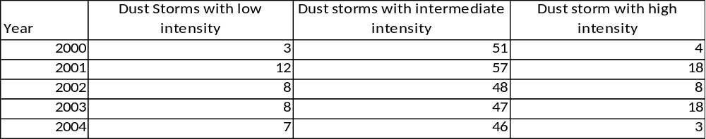
Record of dust storm intensity in Sistan
The observable trends of complaints included running nose, eye irritation, cough, bodily aching, headache, wheeze and asthmatic attacks, and the prevalence followed the order outlined (Meo, A Al-Kheraiji, AlFaraj, Alwehaibi, & Aldereihim, 2013). Bo and team found out that higher concentration of dust decreases the air-gap breakdown voltage, which tends to be lower than the rate of clean air. The team also noted that the voltage increases with increase in speed (Bo, et al., 2010).

The relationship between voltage and air-gap distance (wind speed: 7m/s)
Hu and team found that the aerosols from dust particles of the sandstorm impacted an alteration of the radiation heating rate of the atmosphere; that is, heat in the air was mainly concentrated in the low and middle troposphere, and a consequent cooling of the earth’s surface (Hu, Wu, Li, & Wang, 2017).
Sissakian observed that the Middle East is prevalent to wet seasons from winter all through to spring, whereas the summers are dry all through autumn. Sandstorms are manifest through the summer periods as from the late spring. This is because of the high temperatures that frequently exceed 45ºC in the afternoon, and a consistent temperature of 37°C overnight (Sissakian, Al-Ansari, & Knutsson, 2013). Al-Hemoud analysis showed an average of 8 sandstorms per year within the period of the prior 14 years, which observed a considerable crop production from 500,000 to 900,000 and sales revenue from the same.

Annual number of dust storms
They also observed the sandstorms had a negative effect of GDP by 0.1%. The sea ports recorded a negative impact of the sandstorms of marine traffic, making the maneuverability of the ships hard and forcing the ships to clear from the docks with haste. No direct relationship was determined between sand storms and traffic accidents, but assessment showed the likelihood of significance losses in the Middle East in GDP per annum (Al-Hemoud, Al-Sudairawi, Neelamanai, Naseeb, & Behbehani, 2017).
Ischaemic heart disease hospital admission was closely associated with significantly high sandstorm metrics, with an inconsistency observed when analyzing the effect of the lag structure across the indicators for sandstorm. In the days where the region experienced sandstorms, hospital admissions increased by 16-21%. The results also illustrate the effect of pollutants from the transportation industry. Cerebrovascular admissions observed to associate with CO and PM10 with both experiencing lag of 3 days. SO2 exhibited no relations with hospital admissions. Asthma records a rise of 4.48% with 28unit increment of LO3 PM10 and a significant increase of 7.60% when the LO3 ozone increased with each 10 ppb (Bell, Levy, & Lin, 2010).
The test found that small particle when dry could be blown off the flexible plate once the effects of abrasion were studied. Silt was also subjected to wind erosion according to how dry the specimen was. The cohesion of clay was noted and analyzed in relation to wind erosion (Day, 2010). The results obtained by Lee and team indicated statistical significant relationship between Asian dust storms and the mortality rates in the three cities adopted for the study (Hyewon, Ho, Yasushi, Yue-Ling, Youn-Hee, & Na-Kyung, 2014). Adverse effects were noted for analysis of effects of Asian dust storms and mortality of Kitakyushu, and a significant negative effect was also noted on the same base for Taiwan. A similar note was found for the sensitivity analyses in consistency and analyses which was not believed to be coincidental. The study aso noted that effects could differ by the geographical distributions and characteristics independent of the origin the dust storms. The PM10 concentrations recorded were 71.4 units for the days enduring the storm whereas days free from storms recorded 49.6 units. The time analyses series were based on an earlier study derived significant differences in findings were attributed to the change in study populations. The study noted the effects of global warming manifesting as climate change, and rapid industrialization, both of which accelerated desertification of the regions facilitating formation of more sand storms. The study recommends the development of dust storm warnings in an effort to protect the people from the effects of dust storms (Hyewon, Ho, Yasushi, Yue-Ling, Youn-Hee, & Na-Kyung, 2014).

Conclusion
According to Miri and team, the Zabol region experienced losses estimated to cost about US $1213.976 million within the years 200-2004 from activities of house cleaning in the aftermath, to enforced school breaks.
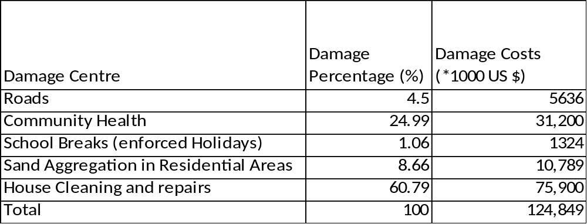
Cumulative damage costs of sand storms in Zabol region during 2000-2004
The study demonstrated how ineffective compensation methods are as a means to combat the effects of sand storms and also highlighted the benefits of desertification of land. Green belts creation along the shoreline as a control and regulation measure of dust storms which originate from the Hamoun Lake was also a credible regeneration protocol (Miri, Ahmadi, Ekhtesasi, Panjehkeh, & Ghanbari, 2009).

Mean monthly average number of days with dust storms in Sistan region during 2000-2004
Meo and team research concludes that exposure to sandstorms has several general health, psychological, insomnia and respiratory issues. Unnecessary exposure and a wider range of protective and preventive measures is advised. Osama and team back up these findings be demonstrating the adverse pulmonary effects especially to patients with a history of chronic obstructive pulmonary diseases, asthma, and allergies. The team demonstrates the high risk factors in mortality and morbidity rates associated with the Arabian storms (Samarkandi, Khan, Alazmy, Alobaid, & Bashatah, 2017). According to Bo’s research the higher the presence of particles in the sandstorm, the lower the chances of electrocution (Bo, et al., 2010). The research also notes that stronger winds increase the chances of the insulators’ electrical conduciveness. According to Hu and team, even if the climate situations were impacted with intense and continuous sandstorms, the aerosols observed enhanced moisture loss and diabatic heating which consequentially made the surface and environment warmer and dryer (Hu, Wu, Li, & Wang, 2017).
According to the observations of Sissakian and team, the season experienced low humidity and moisture content, with minimal dew points, and a substantial decrease in rainfall which consequentially reduces the amount of water-flow (Sissakian, Al-Ansari, & Knutsson, 2013). Al-Hemoud information was very productive for long-term economic effects of sandstorms. There was a weak connection determined between the storms and agriculture with notable increase in revenues from 30 to 80 million KD in the sector within a 14 year period.
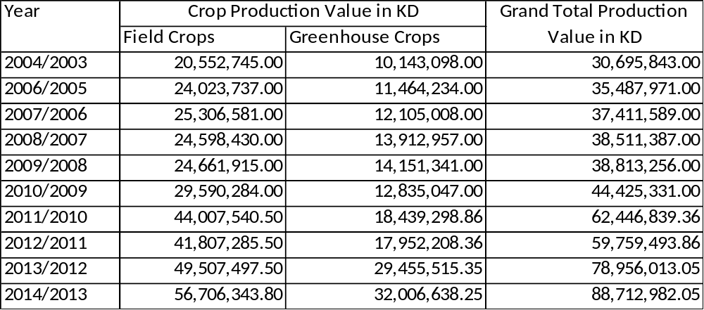
The tactical costs brought about by the delay in flights from Kuwait were assumed to be twice the same analysis for Europeans, with consequential negative effects on productivity of the airlines in ground traffic and bagged transportation. The cost on the marine front was analyzed to estimate US $114 million in revenue from oil export which impacted inflation negatively. The correlation of traffic accident to sandstorms was weak (r=0.354), but the total analysis of cost from traffic accidents estimating to $340 million which is 0.2% of GDP. Al-Hemoud also analyzed that an increase in the sandstorms will amount to losses of US $12.7 billion in GDP per annum for North Africa and the Middle East, with the former enduring significantly higher losses among the two (Al-Hemoud, Al-Sudairawi, Neelamanai, Naseeb, & Behbehani, 2017). Bell and the team observed that in Taipei, sandstorms and pollutants are crucial determinants and evaluators of the risk of hospital admissions, but they failed to demonstrate the magnitude and the structure of lag of such effects (Bell, Levy, & Lin, 2010).
The study found that for silt, any moisture content recorded below 10% resulted in high susceptibility to wind erosion. There was a direct relationship between cohesion and susceptibility for clay; significant cohesion reduced the susceptibility of the specimen (Day, 2010). The study did not find anything substantial about specific moisture content of the samples that regulated the behavior of wind to erode surfaces. Lee and team conducted a study to evaluate the impact of Asian dust storms in three cities and found that the affected size and direction pattern differed among the three cities (Hyewon, Ho, Yasushi, Yue-Ling, Youn-Hee, & Na-Kyung, 2014). The specificity of the effects presented as protective in Taipei, whereas the dust storms presented as adverse effects in Seoul and Kitakyushu. The lag effects of the dust storms were different in the structures and subgroups. The analyses adopted highlight the effects as global issues and hence calls for further studies but highlight the fundamental part global warming and industrialization plays to accelerate desertification and demonstrates how effective warning systems would positively impact health outcomes.

References
Al Ramahi, N. (2018, July 30). Dust Storm Causes 1,000 Road Accident in Dubai. Retrieved May 17, 2019, from The National UAE: https://www.thenational.ae/uae/dust-storm-causes-1-000-road-accidents-in-dubai-1.755592
Al-Hemoud, A., Al-Sudairawi, M., Neelamanai, S., Naseeb, A., & Behbehani, W. (2017, January). Socioeconomic effect of dust storms in Kuwait. Arabian Journal of Geosciences .
Bell, M. L., Levy, J. K., & Lin, Z. (2010). The effect of sandstorms and air pollution on cause-specific hospital admissions in Taipei, Taiwan. Occupational and environmental medicine , 65 (2), 104-111.
Bo, H., Gang, Z., BangFa, C., NaiKui, G., YaoZhong, l., ZongRen, P., et al. (2010). The influence of the sand-dust environment on air-gap breakdown discharge characteristics of the plate-to-plate electrode. Science China Physics, Mechanics and Astronomy , 53 (3), 458-464.
Day, R. W. (2010). "Accidents on interstate highways caused by blowing dust.". Journal of performance of constructed facilities , 7 (2), 128-132.
Hu, T., Wu, D., Li, Y., & Wang, C. (2017). The Effects of Sandstorms on the Climate of Northwestern China. Advances in Meteorology .
Hyewon, L., Ho, K., Yasushi, H., Yue-Ling, G., Youn-Hee, L., & Na-Kyung, K. (2014). "Effects of Asian dust storms on mortality in three Asian cities.". Atmospheric Environment , 89, 309-317.
Meo, S. A., A Al-Kheraiji, M. F., AlFaraj, Z. F., Alwehaibi, N. A., & Aldereihim, A. A. (2013). Respiratory and general health complaints in subjects exposed to sandstorm at Riyadh, Saudi Arabia. Pakistan Journal of Medical Sciences , 29 (2), 642-646.
Miri, A., Ahmadi, H., Ekhtesasi, M. R., Panjehkeh, N., & Ghanbari, A. (2009). "Environmental and socio‐economic impacts of dust storms in Sistan Region, Iran.". International Journal of Environmental Studies , 66 (3), 343-355.
Samarkandi, O. K., Khan, A. A., Alazmy, W., Alobaid, A. M., & Bashatah, A. S. (2017). The pulmonary consequences of sandstorms in Saudi Arabia: a comprehensive review and update. American Journal of Disaster Medicine , 12, 179-188.
Sissakian, V. K., Al-Ansari, N., & Knutsson, S. (2013). Sand and Dust Storm Events in the Middle East. Natural Science , 5 (10).

Appendices

The relationship between voltage and air-gap distance (wind speed: 7m/s). (Bo, et al., 2010)

(Al-Hemoud, Al-Sudairawi, Neelamanai, Naseeb, & Behbehani, 2017)
(Al-Hemoud, Al-Sudairawi, Neelamanai, Naseeb, & Behbehani, 2017)
(Miri, Ahmadi, Ekhtesasi, Panjehkeh, & Ghanbari, 2009)

Mean monthly average number of days with dust storms in Sistan region during 2000-2004 (Miri, Ahmadi, Ekhtesasi, Panjehkeh, & Ghanbari, 2009)
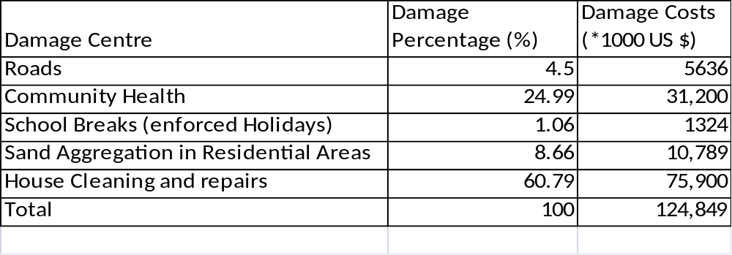
Cumulative damage costs of sand storms in Zabol region during 2000-2004 (Miri, Ahmadi, Ekhtesasi, Panjehkeh, & Ghanbari, 2009)

